Paralympics Australia

Strategic Plan – Horizon 2 – LA 2028

UPLIFT

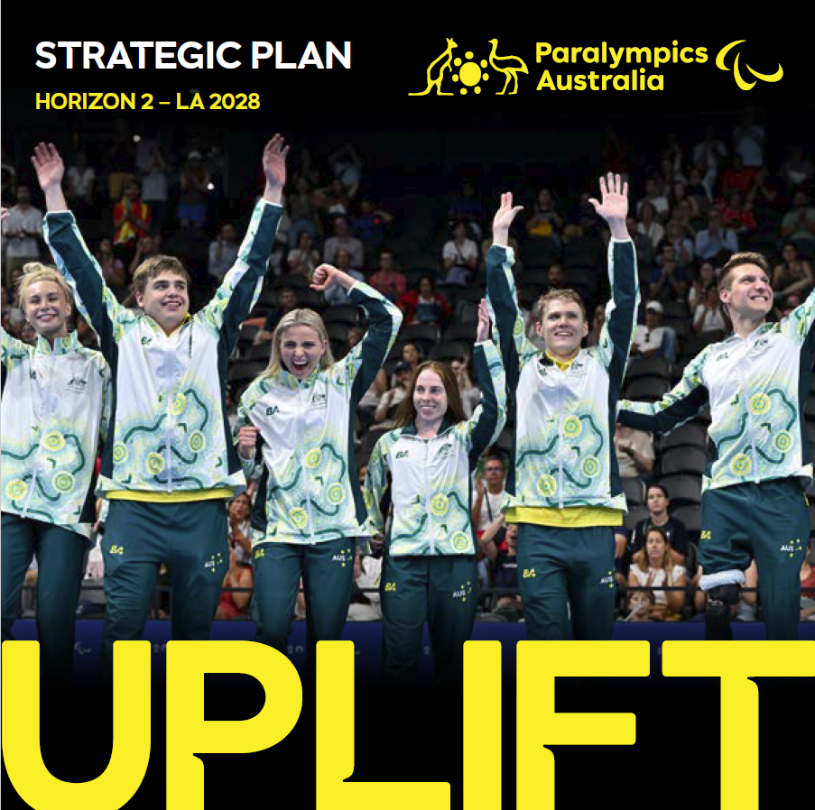

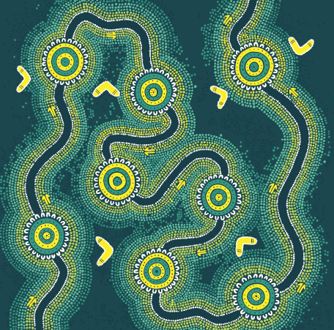

Acknowledgement Of Country
Paralympics Australia acknowledges and pays respect to Elders past and present of the lands and waters on which we live, work, and engage in sports together. We are committed to caring for those lands and people across the nation.

We acknowledge the diversity, unique histories, cultures, knowledge, and current experiences of individuals and communities across Australia. We celebrate their contributions to the nation broadly, and specifically to community and sport.

‘The Journey, ’artwork, featured above, created by First Nations artist Rheanna Lotter,
symbolises the Australian Paralympic family - individuals from diverse backgrounds and regions, each with unique challenges they’ve overcome, united in a shared story.

Paralympics Australia recognises the 16 known First Nations Paralympians that have represented the Australian Paralympic Team since our first Games in 1960.

Aboriginal and Torres Strait Islander people should be aware that this document contains images and names of deceased First Nations persons.

Our Why

The Australian Paralympic Movement is a catalyst for change beyond sport. The Movement creates opportunities for people with disabilities to connect, grow and thrive. From the grassroots level to the world stage, we break down barriers and back the dreams of Para athletes determined to compete at the highest level.

Why is this important? Every competition and every story that we share has the power to change perceptions and bring us closer to a more inclusive Australia.

Para sport changes lives, inspires confidence, fosters community and social cohesion, and provides a sense of purpose. Our impact extends far beyond the field of play.

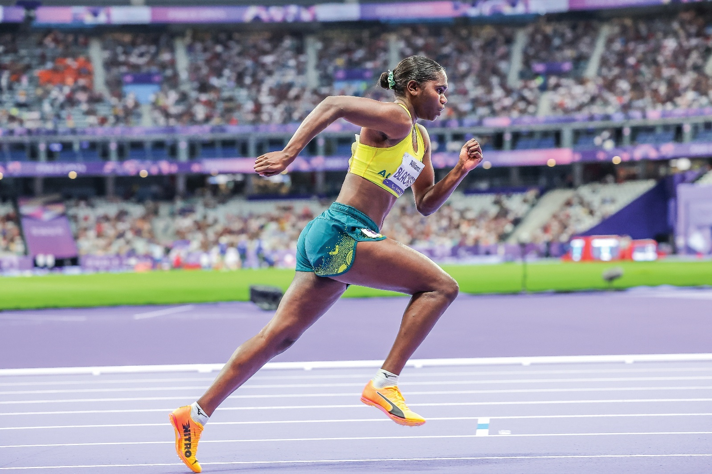

Why It Matters

We bring people together through the power of Para sport. We show
up where it matters most for those we support:

Para athletes & Paralympians
- Aspiring Para athletes: empowering the start of their Para sport journey through pathways, promotion and education.
- Current Para athletes and Paralympians: enabling access, development and the opportunity to compete at the highest level.
- Alumni: creating meaningful roles for Paralympic alumni to mentor and support the next generation.

Supporters
- The Australian public: elevating the power of the human spirit through Para sport and uniting communities by driving social cohesion and genuine connection.
- Donors: demonstrating the impact of their support for Para athletes and people
with disability.
- Philanthropic investors: enabling long-term change by funding sustainable programs to further the impact of the Australian Paralympic Movement.
- Government: enabling investment to drive positive change in society.
- Corporate partners: inviting business to champion inclusion, social change and acceptance within the workplace.

Sporting Community
- Coaches & allied health professionals: providing education and resources to help identify and nurture emerging talent.
- National sports system: leading classification and supporting system partners to deliver best-practice high-performance programs.

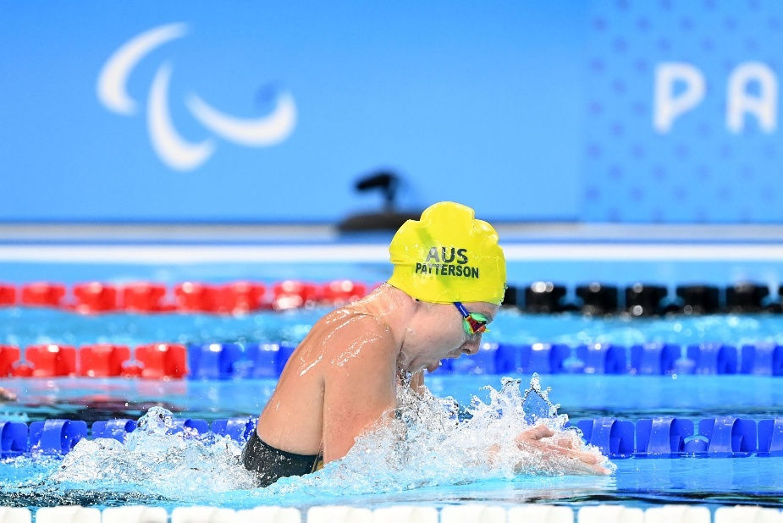
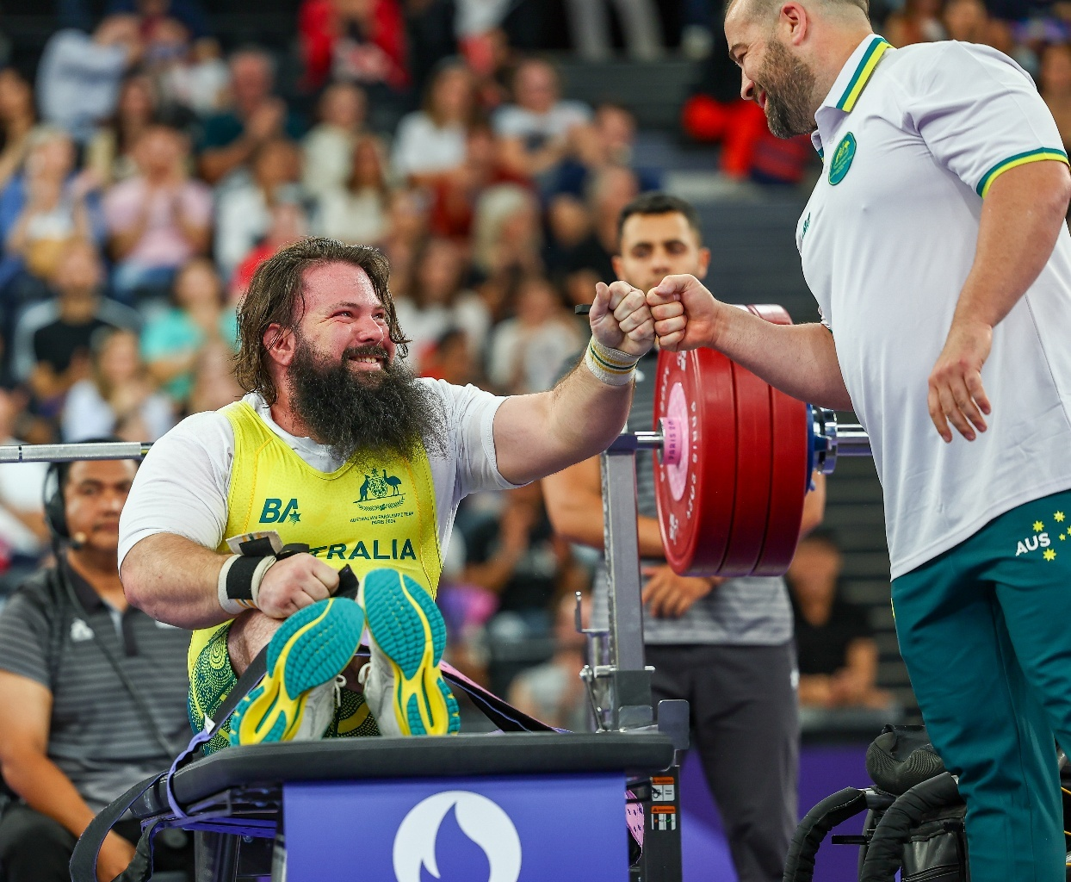

Who We Are

Paralympics Australia is the nation’s peak sporting organisation for athletes with a disability. We are a National Paralympic Committee, a member of the International Paralympic Committee and operate to connect, facilitate, innovate and advocate for Para sport.

At the heart of our ambition is our athletes, who strive to represent the nation, honour our past and uphold the ideals of the Australian Paralympic Movement.

Our responsibilities include preparing, managing and delivering Australian teams to the Paralympic Summer and Winter Games. We work with valued partners from Government, National Sporting Organisations, the National Institute Network and others to identify, develop and support Paralympic talent.

We are committed to building a world-class sporting system to enable our athletes and teams to reach their full potential.

More broadly, we help Australians engage in Para sport because we believe it provides physical and social benefits and plays an important role in changing community perceptions of people with disabilities.

As the premier peak body and a registered charity, our partnerships are critical to achieving our goals.

We are:
- Australia’s National Paralympic Committee and a member of the International Paralympic Committee.
- The peak body for Paralympic sport in Australia, as recognised by the Australian Sports Commission.
- Responsible for the organisation, management and delivery of the Australian Paralympic Team.
- Responsible for the classification of Para athletes in Australia under the
- IPC Classification Code.
- The National Sporting Organisation for Para powerlifting.
- A registered charity.
- A Brisbane 2032 Games Delivery Partner.

Our Members

- Archery Australia  - Australian Athletics  - AusCycling  - AusTriathlon  - Australian Sailing  - Australian Taekwondo  - Badminton Australia  - Basketball Australia  - Biathlon Australia  - Blind Sports Australia  - Boccia Australia  - Disability Sports Australia  - Disabled Wintersport Australia | - Equestrian Australia  - Football Australia  - Ice Hockey Australia  - Paddle Australia  - Rowing Australia  - Shooting Australia  - Sport Inclusion Australia  - Snow Australia  - Swimming Australia  - Table Tennis Australia  - Tennis Australia  - Wheelchair Rugby Australia

Our History

These World War II heroes were expected to quietly die. Injured spines and tortured minds consigned them to the edges of society. But a doctor named Ludwig Guttmann refused their fate.

At his spinal unit at Stoke Mandeville Hospital, sport was the path to rehabilitation. His insight unlocked an almighty element of the human spirit.

At Royal Perth Hospital Dr George Bedbrook followed Guttmann’s lead. When Guttmann challenged Bedbrook to send over a sporting team, Bedbrook obliged and in 1957 Australia’s first disability athletes competed at the Stoke Mandeville Games - the pre-cursor to the Paralympic Games.

Our daring dozen pioneers of Rome 1960 – the first Paralympic Games – sold raffle tickets to pay their passage. They were carried onto aircraft and stayed in barely accessible accommodation.

One was forced to use a British passport, lest our country recognise his heritage. Kevin Coombs was Australia’s first Indigenous Paralympian.

Since that first Games, the Australian Paralympic Team has forged a rich and proud history - not without its challenges.

On three occasions the Olympic Host City declined to host the Summer Paralympic Games, in 1968, 1972 and 1980. Little do people remember history was nearly repeated in Sydney, before a last-minute deal struck with the NSW Government secured the winning votes for the 2000 Olympic and Paralympic Games.

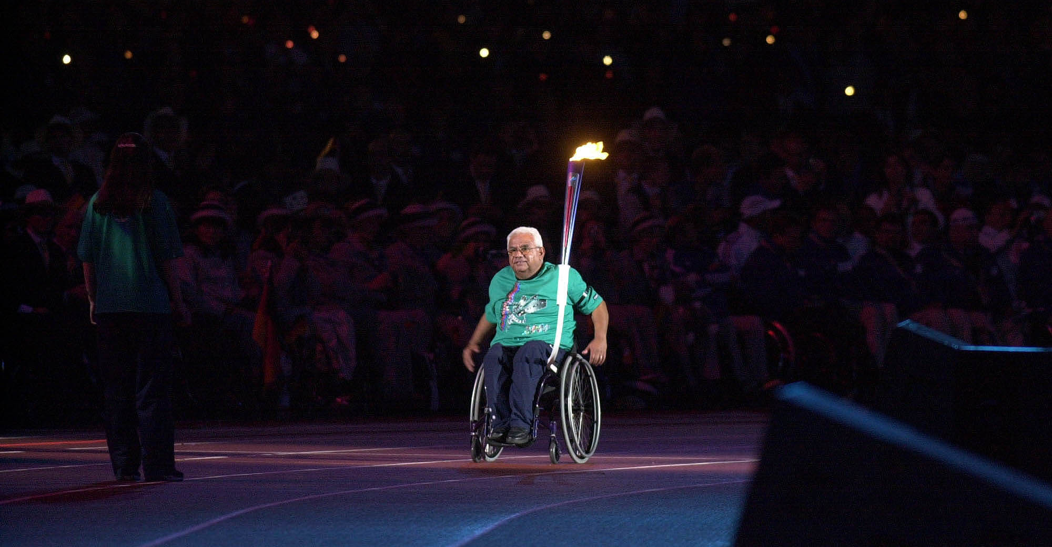

Our Story Continues

From the inclusion of amputees and vision impaired athletes in competition from Toronto 1976, the announcement of Sydney 2000 sparking change and investment in Australian sport, to the first Australian commercial television broadcast of the Paralympic Games at Rio 2016, the profile and reach of the Paralympic Movement has
continued to increase.

What started out as treatment for injured soldiers has led to genuine change in perceptions of people with a disability and the opportunities they have their lives.

Today, the Paralympic Games is a vast elite sporting event… yet it’s so much more. It’s a social movement that fights discrimination and outdated narratives. It’s a vanguard of science and technology that impacts the lives of millions of people. And it’s without doubt the biggest celebration of inclusion and diversity the world has ever known.

1,187 athletes have represented Australia at the Paralympics. They are The Mob. On the road to Brisbane 2032 this is the moment to Imagine What We Can Do.

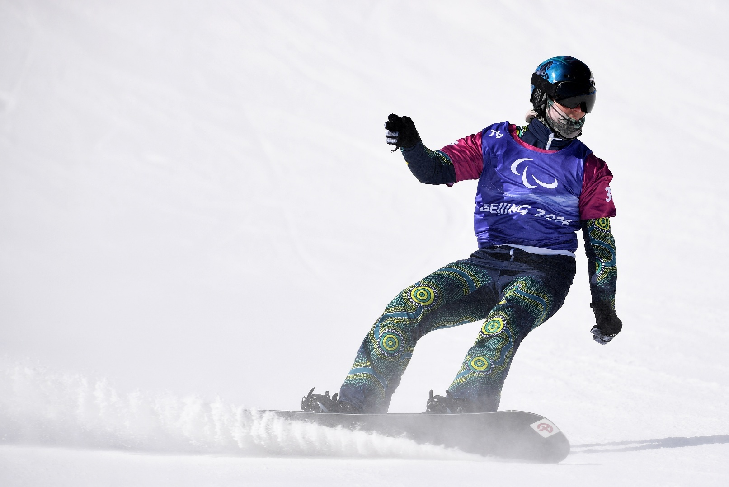

Quote - Lauren Parker OAM PLY

“If I didn’t have sport, I don’t know where I’d be. It gives me a focus, a goal, a purpose in life.”

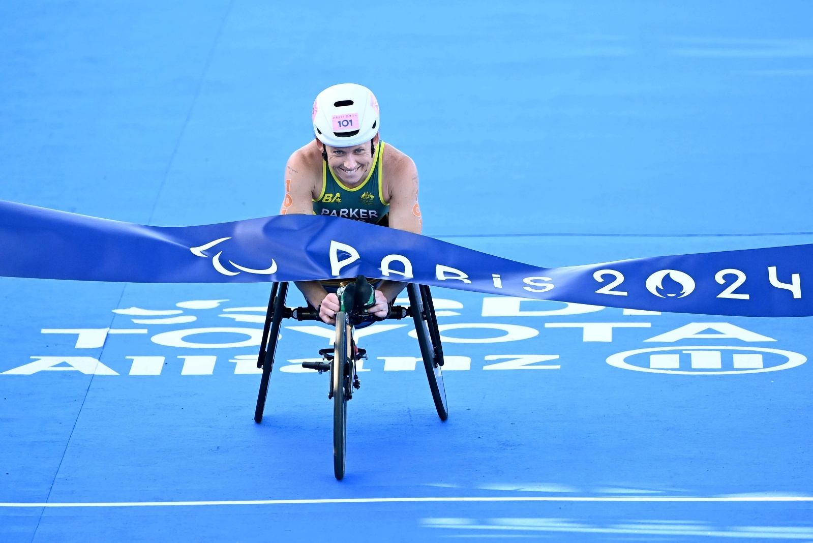

Lauren Parker OAM PLY: Para triathlon PTWC1, Para cycling H3, Paris 2024 dual gold medallist and 2024 Paralympian of the Year.

Our Strategy

Purpose
We exist to lead Paralympic sport and create a more inclusive world.

Vision
To create the most successful era of Paralympic sport in Australia’s history.

Ambitions
- A world-leading and equitable sport system.
- Remarkable Paralympic performance.
- Our Team is a source of Aussie pride and a force towards creating a more inclusive society.

Strategic Pillars and Priorities

Our Team | Our Ecosystem | Our Story | Our Future
- Provide a world-leading performance environment for the Australian Paralympic Team at the Summer and Winter Paralympic Games to demonstrate the power of human performance.  - Lead the growth of Para powerlifting as the National Sporting Organisation to drive visibility and competitive success. | - Lead, support and advise the Para System Uplift aligned with our Win Well 2032 commitment.  - Lead national classification system enhancement.  - Support, engage and deliver value to our members, Para athletes, Paralympians and Paralympic alumni. | - Inspire the next generation of Paralympians and fans through increased promotion and growth of the Paralympic Movement in Australia.  - Position the Australian Paralympic Movement as a champion for inclusion, social impact and an enduring legacy through the power of Para sport. | - Secure the sustainable future of Paralympics Australia and the Australian Paralympic Movement.

Our Enablers
People, Platforms, Processes, Partnerships

Our Values
Brave, Limitless, Tenacious, Proud

Strategic Pillar: Our Team

Strategic Priorities
- Provide a world-leading performance environment for the Australian Paralympic Team at the Summer and Winter Paralympic Games to demonstrate the power of human performance.
- Lead the growth of Para powerlifting as the National Sporting Organisation to drive visibility and competitive success.

Strategic Initiatives
- Deliver a World-Class Performance Environment: Continuously enhance athlete performance support, wellbeing, safety, security and resources at Summer and Winter Paralympic Games.
- Exhibit Regional and International Leadership: Show regional leadership and provide enhanced support for the Paralympic Movement in Oceania and internationally. Foster collaboration, develop strategic partnerships, and share best practices to strengthen the influence and reach of the Paralympic Movement globally.
- Develop Para Powerlifting Program: Implement programs to advance Para powerlifting, enhancing coaching, increasing participation, and fostering high performance to align with global standards.

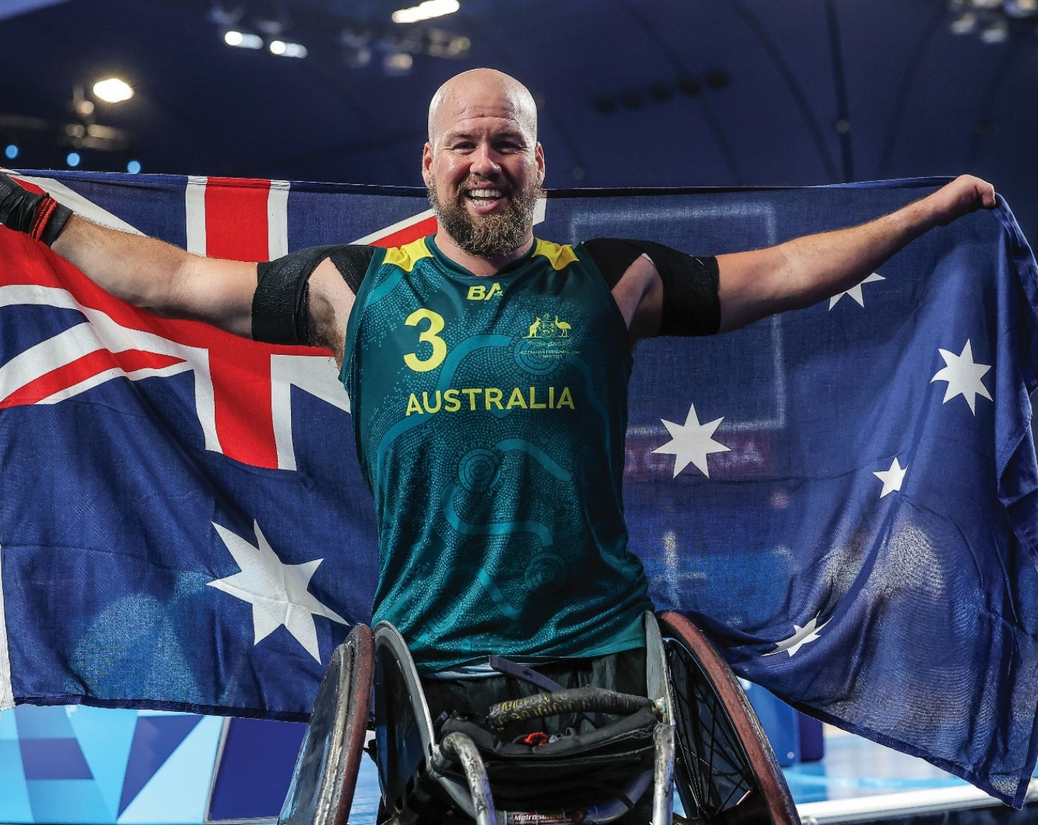

Strategic Pillar: Our Ecosystem

Strategic Priorities
- Lead, support and advise the Para System Uplift aligned with our Win Well 2032 commitment.
- Lead national classification system enhancement.
- Support, engage and deliver value to our members, Para athletes, Paralympians and Paralympic alumni.

Strategic Initiatives
- Revolutionise the Classification System: Implement a streamlined and nationally integrated classification system that aligns with international standards, significantly improving athlete experiences.
- Accelerate Talent Identification and Development: Lead and support targeted talent identification initiatives that enhance progression for future Paralympians.
- Equip Athletes for Success: Oversee the Para sport Equipment Enhancement Program to ensure equitable access to specialised, fit-for-purpose Para sport equipment.
- Leverage our High-Performance Partnerships: Drive and support the world-leading Para System Uplift, enhancing athlete pathways in alignment with Win Well 2032.
- Deepen Member Support and Collaboration: Enhance strategic relationships with our members by consistently providing support and meaningful engagement opportunities that directly align with our strategic goals and enrich Para sport experiences.
- Support Alumni: Engage with Paralympic alumni to identify opportunities to support their post-athletic relationship with the Paralympic Movement.

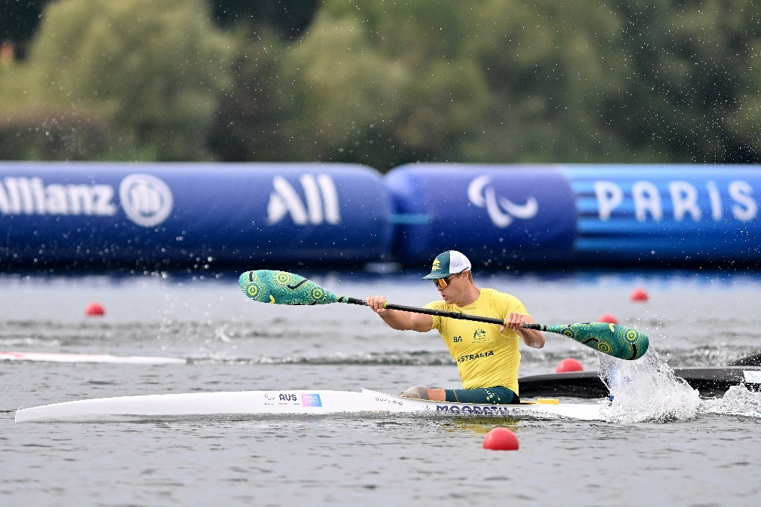

Strategic Pillar: Our Story

Strategic Priorities
- Inspire the next generation of Paralympians and fans through increased promotion and growth of the Paralympic Movement in Australia.
- Position the Australian Paralympic Movement as a champion for inclusion, social impact and an enduring legacy through the power of Para sport.

Strategic Initiatives
- Deliver bold communication and engagement campaigns: Tell the compelling stories of current and future Paralympians and Paralympic alumni that instil national pride in the Australian Paralympic Movement.
- Increase awareness and support for the Australian Paralympic Movement: Communicate and engage with the Australian community to attract Para athletes, fans, donors and partners that will champion the power of Para sport.
- Create social impact through the power of Para sport: Provide the platform for Paralympians and Para athletes to positively impact communities, challenge perceptions and promote a more inclusive and equitable society.

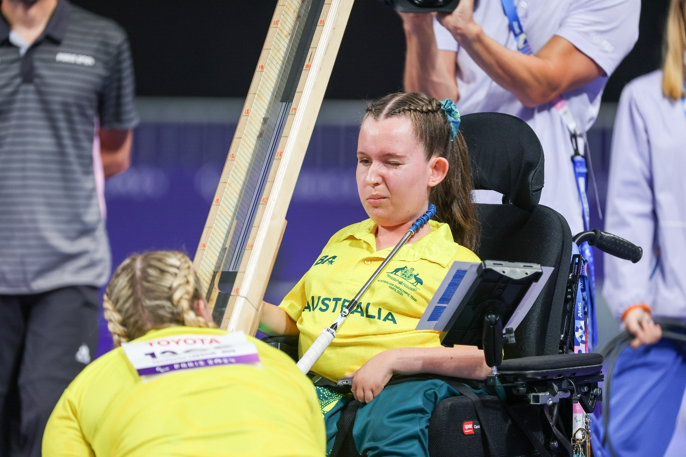

Strategic Pillar: Our Future

Strategic Priorities
- Secure the sustainable future of Paralympics Australia and the Australian Paralympic Movement.

Strategic Initiatives
- Leverage the Brisbane 2032 Games: Engage in initiatives that will propel the Brisbane 2032 Olympic and Paralympic Games to be the most accessible ever, ensuring a transformative legacy that enhances accessibility and inclusivity for Para sport and the broader community.
- Ensure Financial Sustainability: Achieve financial sustainability by expanding and diversifying revenue streams through Government engagement and innovative commercial and philanthropic strategies.
- Establish a Future Fund: Establish a Future Fund to underpin the financial security of Paralympics Australia and the Australian Paralympic Movement.
- Enhance Organisational Sustainability: Empower and engage our people and embed effective systems and governance to build organisational strength and agility.
- Solidify Equitable Funding: Advocate for continued equitable funding for Para sport from all sectors and industries.

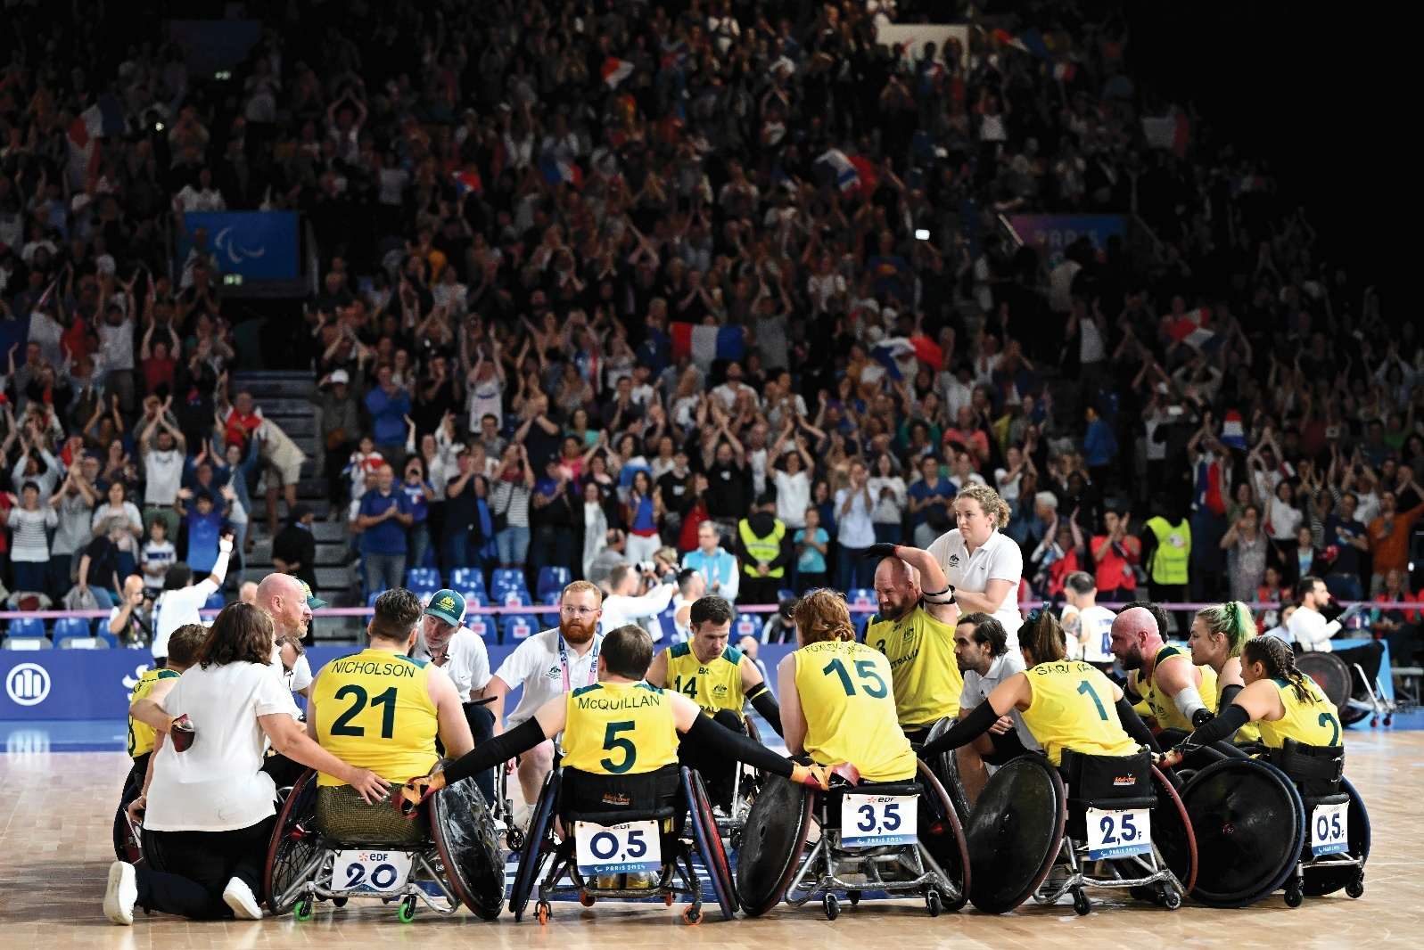

Enabling Our Strategic Plan

At Paralympics Australia, we are committed to delivering meaningful outcomes through our Uplift strategy. This is more than just a plan - it’s a promise to advance our Movement with purpose, precision and impact.

To ensure our strategy drives measurable results, we will take a disciplined and accountable approach to planning, execution and reporting. By focusing on our people, platforms and processes, operational excellence will be embedded into everything we do.

Continuous improvement will be a focus across our strategic pillars of Our Team, Our Ecosystem, Our Story and Our Future. By working closely with our system partners, our strategic initiatives will pursue excellence for our athletes and broader stakeholders.

Creating the most successful era of Paralympic sport in Australia’s history will require our people to lead with purpose. By strengthening and living our organisational values - Brave, Limitless, Tenacious and Proud - and fostering innovation and learning, we will empower our people to lead change and deliver results.

Together, we will transform strategy into sustained performance, ensuring that Paralympics Australia continues to inspire, uplift and lead with impact.

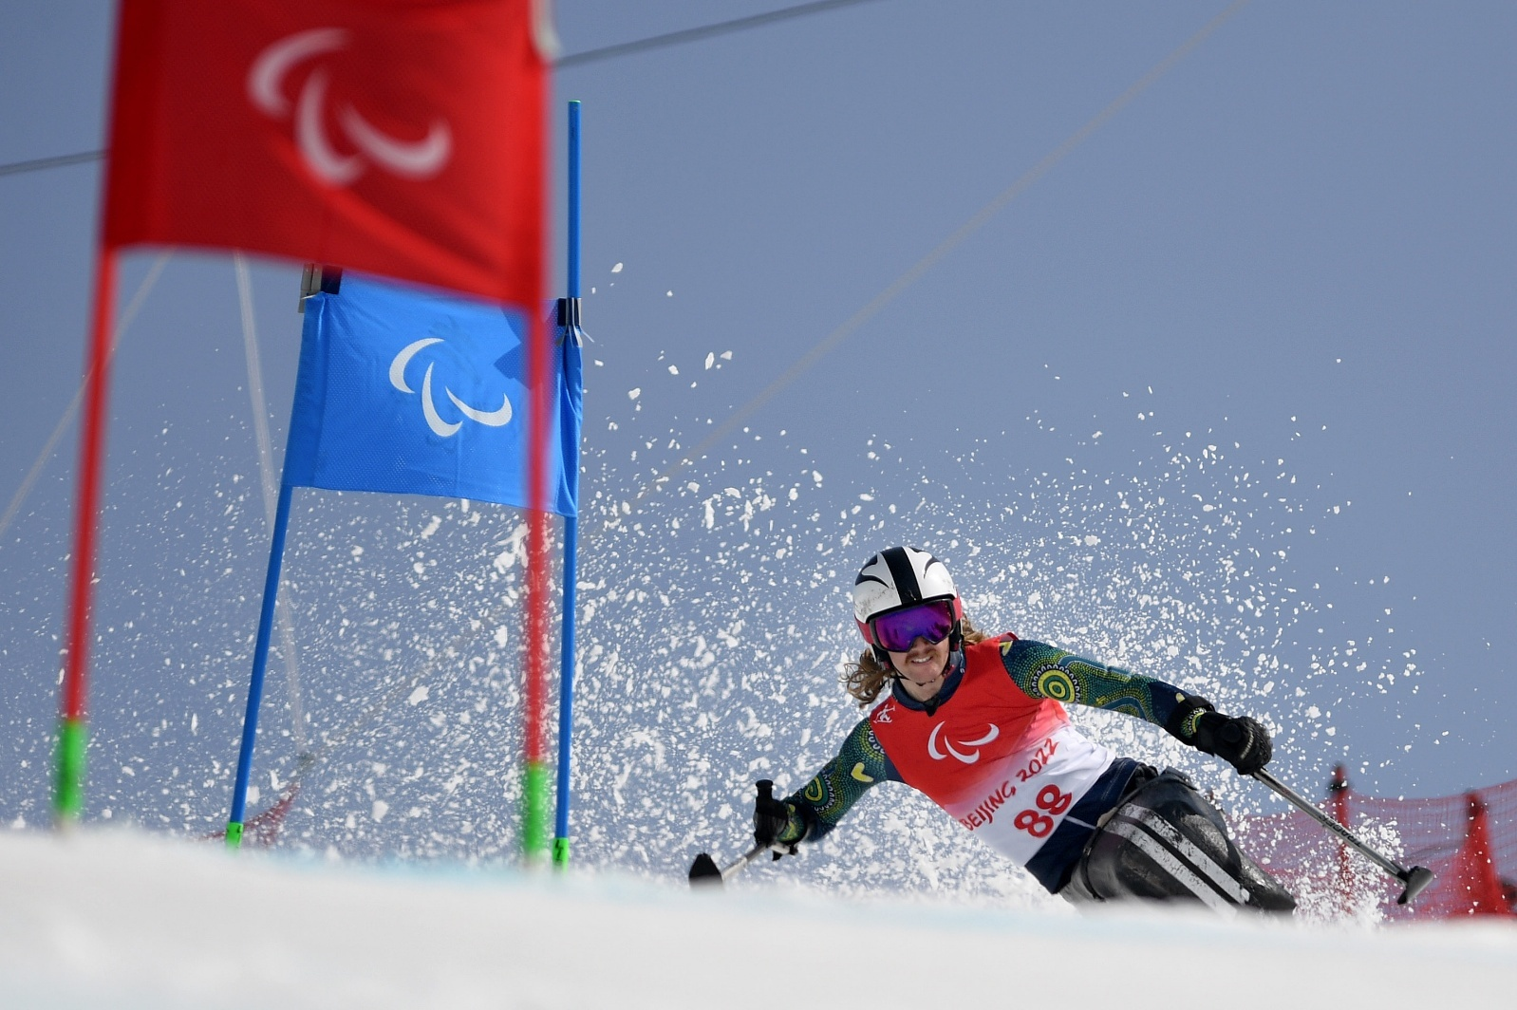

Horizon 1: A Foundation For The Future

As we embark on Horizon 2 of our Strategic Plan, we reflect on the achievements of Horizon 1, which laid the foundation for success towards Brisbane 2032 and beyond. A landmark $54.9 million Federal Government investment signals a generational shift, supporting a more inclusive, equitable high-performance sport system where Para athletes can thrive and inspire Australians for years to come.

We are grateful to Federal and State Governments for this historic co-investment, which addresses systemic barriers and sets us on course to Win Well at our best Games ever in 2032 and beyond. This funding also strengthens our pathway to LA 2028 and aligns with Australia’s High Performance 2032+ Sport Strategy, recognising Para sport as integral to the national sporting framework.

For Paris 2024, parity in athlete support between Olympic and Paralympic teams was achieved for the first time through the Paralympic Team Appeal, with state and
territory support contributing to key costs like travel, accommodation, equipment and medical needs.

These strategic investments are vital to our future. As we look ahead to Milano Cortina 2026 and LA 2028, strong partnerships and shared commitment will drive performance, impact and a lasting legacy of inclusivity and excellence in Australian sport.

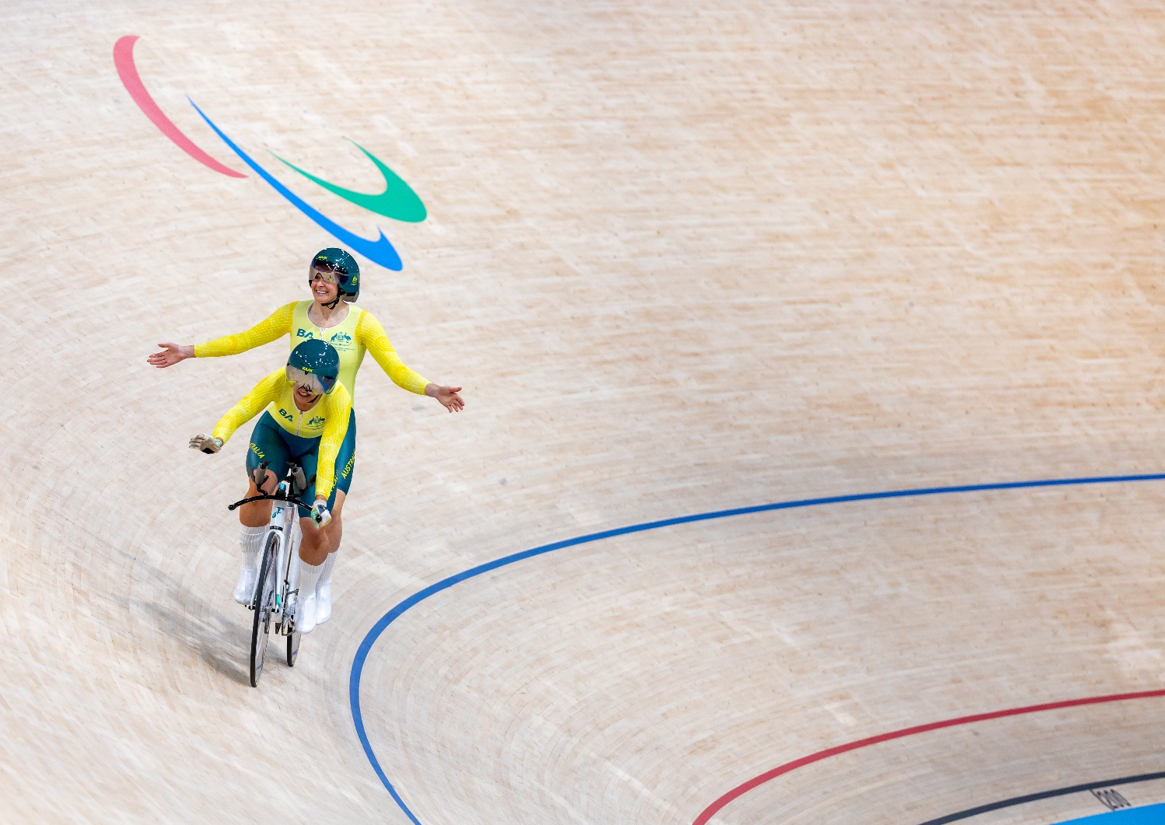

Horizon 1 Achievements

Sustainability
- Record commercial revenue for Paris 2024 cycle.
- Equal funding for the first time from State and Territory governments for the Australian Paralympic and Olympic teams.
- Largest media rights deal in the history of the Australian Paralympic Movement.

Ecosystem
- Record investment of an additional $54.9 million for Para system uplift
Establishment of a centrally-led coordinated and connected national classification system.
- Establishment of Para Sport Units around Australia

Athletes
- Increase of internationally classified Para athletes from 132 to 181.
- Increase of nationally classified Para athletes from 354 to 433.
- Increase of categorised Para athletes from 310 to 355.
- Establishment of the Paralympic Equipment Enhancement Program.

Fans
- Maintained number 1 ranking for Trust, Pride and Respect
- Digital audience growth of 53 per cent.
- 19,339 students engaged in the Imagine Education Program.

At Our Core: Games Delivery Paris 2024
- 63 medals
- 18 Gold, 17, Silver, 28 Bronze
- 5 world records
- Team size : 160
- 61 debutants
- 91.6 per cent athlete satisfaction rating.

The Opportunity Is Now
 | The Australian Paralympic Team continues to rank first amongst Australian National and winter league teams for:  - Respect  - Pride  - Trust  - Bond  Source: True North Benchmark Performance Report, October 2024.
There are 5.5 million Australians (21.4%) living with disability, an increase of 1.1 million since 2018.  Source: Australian Bureau of Statistics, reference period 2022, published 2024. | 

But Challenges Remain
- People with disability are 60% less likely to meet national physical activity guidelines than people without disability.
- The unemployment rate for people with disability is more than double the rate for people without disability.
- Income for people with disability is just 54.5% compared to those without disability.
- We need to increase the number of categorised athletes from 355 to 800 by LA 2028.

What Success Looks Like

Our best Games ever in Brisbane 2032.

- Lead the medal tally.
- Australian Paralympic Team size 300+.
- Improved athlete wellbeing.
- A diverse and inclusive Australian Paralympic Team.
- Enhanced perceptions of Para sport in the Australian community.
- 150 medals from 100 medallists.

How We Get There

WIN WELL in Milano Cortina 2026 and LA 2028.

- Strong Summer and Winter Para sport pathways.
- 800 categorised Para athletes by 2028.
- Increased participation in Para sport.
- A sustainable future for Para sport.
- A strong Australian Paralympic Team culture.

Brisbane 2032
The Brisbane 2032 Paralympic Games represent a once-in-a-generation opportunity to drive meaningful change. As the world’s third-largest sporting event, these Games aim to set a new benchmark for inclusivity and advancing the lives of people with disability within a supportive and celebratory environment.

We are proud to be one of nine Games Delivery Partners, playing a key role in shaping both the planning and delivery of the Olympic and Paralympic Games. Our priority is to maximise our home Games advantage, empower our athletes to excel on the podium and foster national pride, trust and respect.

We will support hosting of major international Para sport events, increasing local competition and international classification opportunities for Australia’s Para athletes, ensuring competitiveness on the global stage.

The impact of these Games will extend far beyond sport. Through the Elevate 2042 Legacy Strategy, Brisbane 2032 will be a catalyst for generational change. We will do this by shifting perceptions, boosting confidence around disability, and fostering a stronger, more inclusive Australia.

By attracting new audiences and celebrating diversity, the Brisbane 2032 Paralympic Games will leave a lasting legacy of pride, possibility and progress for all Australians.

Beyond Brisbane: The Inclusion Revolution
Looking beyond Brisbane 2032, we see the Paralympic Games as a powerful trigger for reshaping perceptions of people with disability and driving lasting systemic change. The legacy of these Games will help advance the Paralympic Movement and foster a more inclusive society.

Central to this vision is equitable funding and a sustainable Paralympics Australia. Strengthening our financial independence is vital to ensure our athletes have the resources to thrive and to secure the future of Para sport in this country.
We are committed to breaking down participation barriers by advocating for universally designed, accessible sporting venues that support athletes and fans at every level.

The Games will also help drive employment, as more organisations embrace diverse and inclusive workforces. Their impact will ripple through communities, inspiring future generations to chase their ambitions without limits.

The legacy we’re building is one of inclusion, equality and possibility. A legacy where diverse abilities are valued and everyone is empowered to reach their potential.

“Hosting the Paralympic Games, the largest event on this planet that puts persons with disabilities front and centre on the world stage, really does have a transformational impact on society.”

Andrew Parsons, International Paralympic Committee President, May 2025

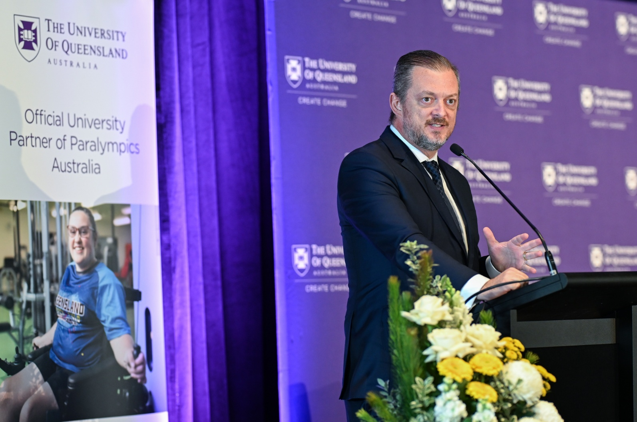

Win Well Pledge

We commit to being an organisation that strives to win well, where how we win is just as important as when we win.  We commit to the holistic development of our athletes and our staff, recognising wellbeing as the foundation of sustainable success.  We commit to leading sport with integrity, where we are accountable for the culture we foster and the decisions we make.  We commit to acknowledging and learning from Aboriginal and Torres Strait Islander Peoples and their cultures, and to walk together as we embed their knowledge and experience into our organisation and build a greater sense of belonging and connection to communities and country.  We commit to a culture of challenge and care so our athletes and staff can perform at their best and reach their potential.  We commit to creating safe and thriving environments for our people to fail so they can learn, grow and succeed.  We commit to being custodians of sport and building a legacy where sport is more inclusive and representative of the diversity of Australian communities.  We commit to WIN WELL. | 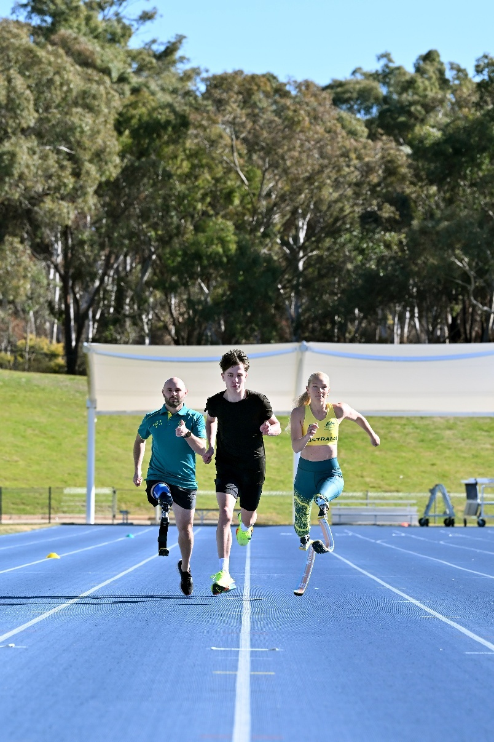

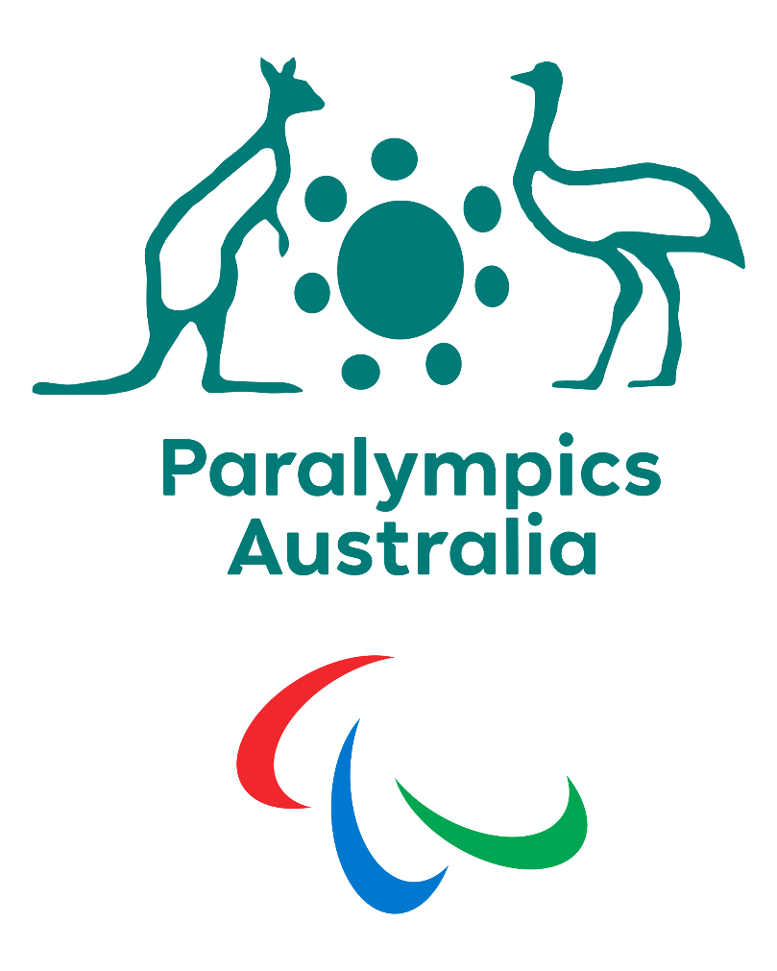

Connect With Us
- Facebook: www.facebook.com/AUSParalympics
- Instagram: www.instagram.com/AUSParalympics
- X: www.x.com/AUSparalympics
- LinkedIn: www.linkedin.com/company/AUSParalympics
- Tik Tok: www.tiktok.com/AUSParaTeam
- YouTube: www.youtube.com/AUSParaTeam
- Website: www.paralympic.org.au

Scan to the QR code to access strategic plan webpage:
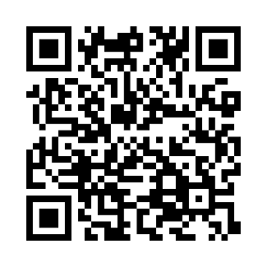
END OF DOCUMENT

