Paralympics Australia Strategic Plan

Horizon 2 – LA 2028

‘UPLIFT’

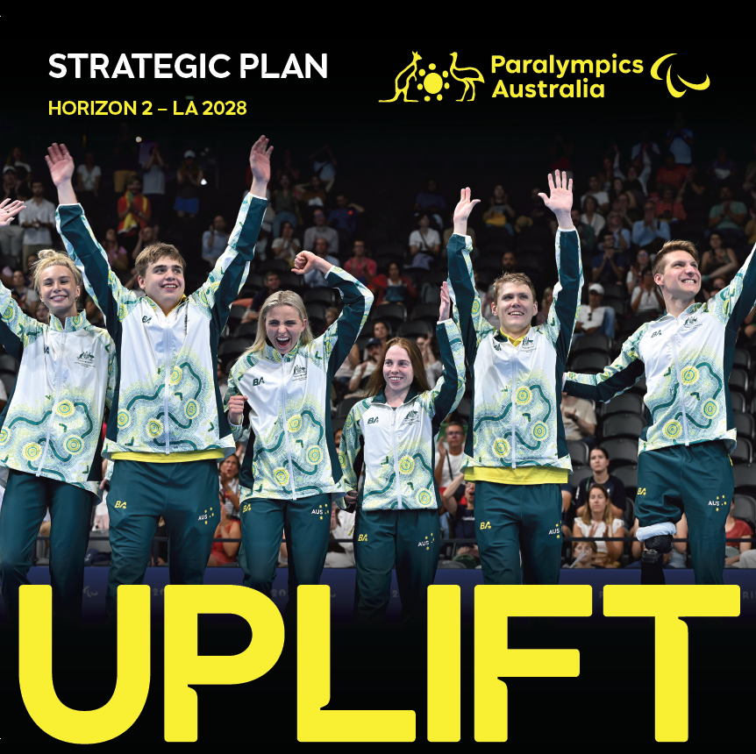

About this document
This information is about Paralympic Australia’s Strategic Plan from 2025 to 2028.

A strategic plan outlines our long-term goals.

It shows how we will achieve these aims.

We have called the plan Horizon 2 – Uplift.

Uplift is our promise to grow Paralympic sport in a strong and meaningful way.

This is the second edition of our strategic plan.

It is one of many plans to help us get ready for the Brisbane 2032 Olympic and Paralympic Games.

The first edition was called Horizon 1 - Imagine.

Acknowledgement of Country
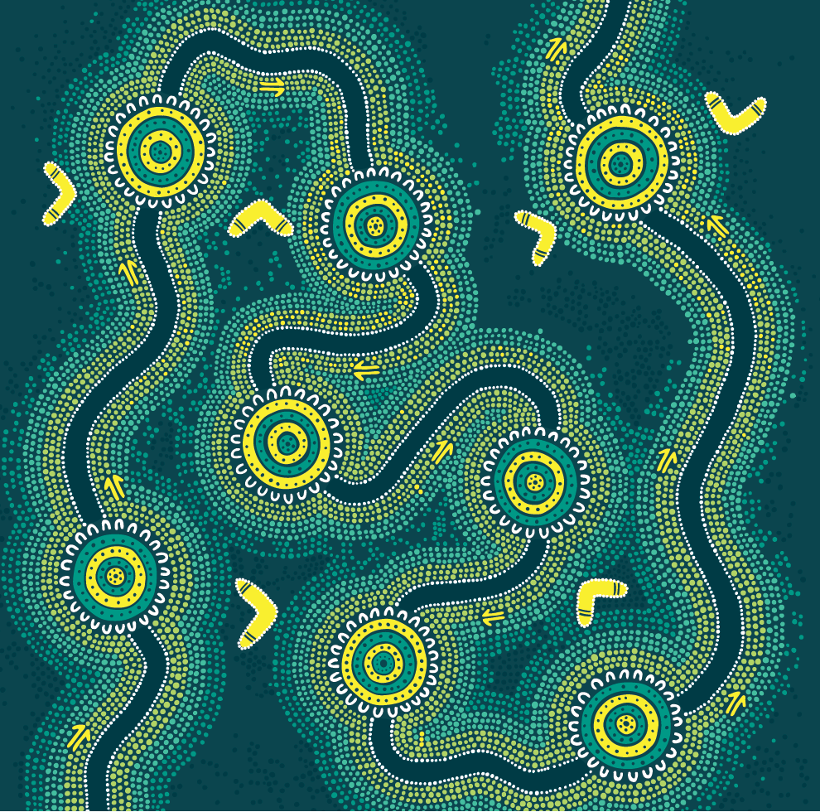 | In this paper we say First Nations People. This means Aboriginal and Torres Strait Islander people.  We know and respect that we work on First Nations land.  We respect the First Nations peoples from all the places where we live, work, and take part in Paralympic sport.  We are proud of the 16 known First Nations people who have been part of the Australian Paralympic Team.  We want to see more First Nations people represent Australia in the future.

How we made this strategic plan
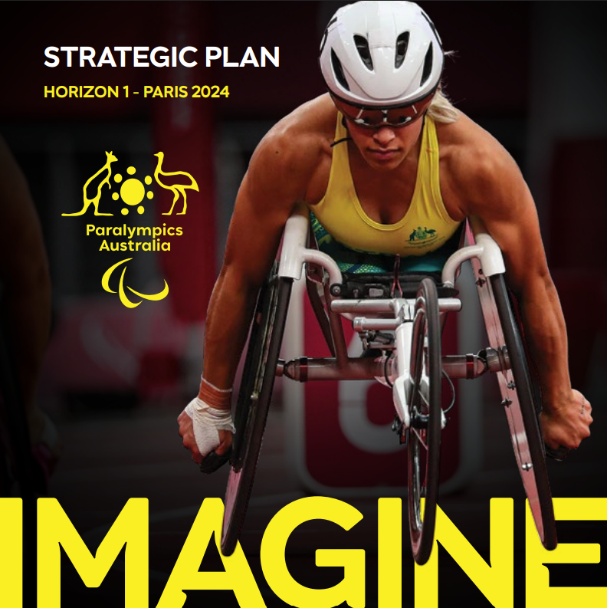 | For Horizon 1 of our strategic plan, we spoke to lots of people who are part of Paralympics Australia.  We also spoke to people who work with Paralympics Australia.
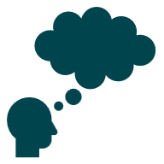  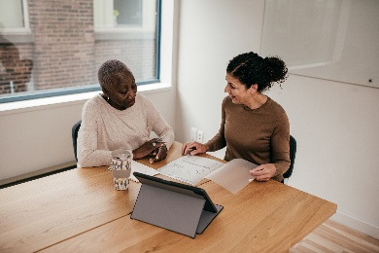 | The plan is called Horizon 2 – LA 2028.  To make this plan we:  - looked at what we wanted to do.  - what we did in the first plan.  - thought about what was different since Horizon 1.  - thought about what may change in the next three years.  - thought about the main things we want to do in the next three years.  - spoke to our employees.  - spoke with the Paralympics Australia Athletes’ Commission.  - The Athletes’ Commission has 13 Paralympians from 10 sports.  - They provide advice to Paralympics Australia.

What Paralympics Australia does
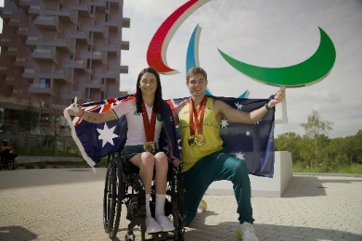 | We are in charge of taking the Australian Paralympic Team to the Paralympic Games.  These Games are contests for athletes with disabilities.  Athletes from all over the world compete.  There are two kinds of Paralympic Games.
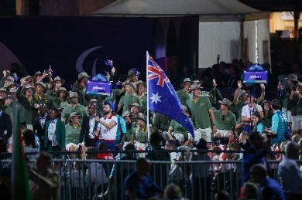 | The Summer Paralympic Games, have 22 sports.  Summer Paralympic Games are held in the same year as the Summer Olympics.  This is every 4 years.  The next Summer Paralympic Games is in 2028.
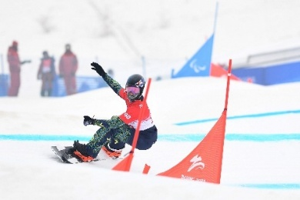 | The Winter Paralympic Games have 6 sports.  The Winter Paralympic Games happen every four years.  The are held soon after the Winter Olympics.  The next Winter Paralympic Games is in 2026.
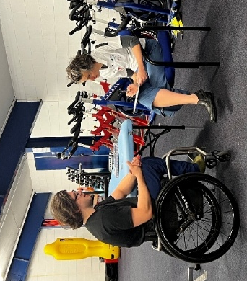 | It is our job to make sure Paralympic athletes are put in the right group for their sport.  These groups are called classifications.
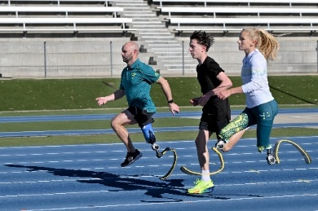 | Classification makes sure that Para athletes take part in events with athletes who have similar impairments.  This makes competition fair for everyone.
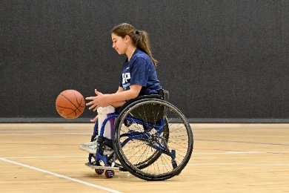 | We want to make sure everyone in Australia has the chance to take part in Paralympic sport.
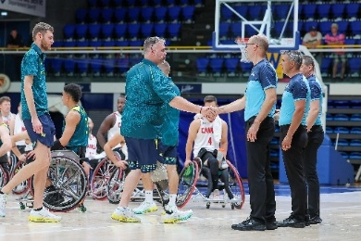 | This could be as:  - an athlete  - a coach  - a staff member  - a fan  - a sponsor  - a parent.

Who Paralympics Australia works with
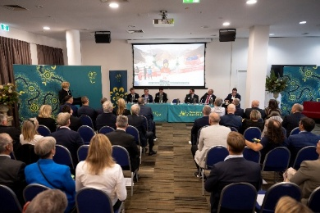 | We work with other groups in Australia to:  - help more people take part in Paralympic sports.  - promote Paralympic sports  Groups we work with include:  - government  - sports clubs  - sponsors  - TV stations  - newspapers  - radio stations
 | We are a member of the International Paralympic Committee.  The International Paralympic Committee looks after Paralympic sport all over the world.
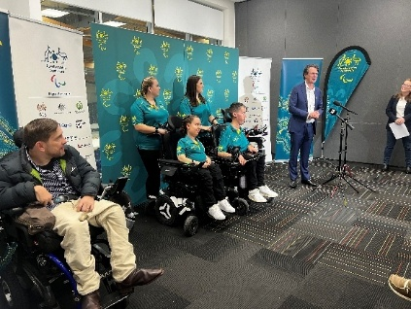 | We have 25 organisations that are members of Paralympics Australia.  These are mostly national sporting organisations like Australian Athletics, Basketball Australia and Boccia Australia.

Our History
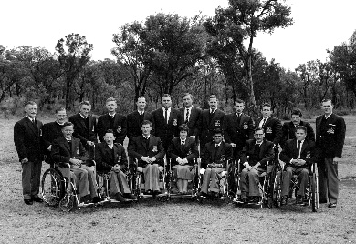 | The Australian Paralympic Team has been to every Summer and Winter Paralympic Games since they began in 1960.
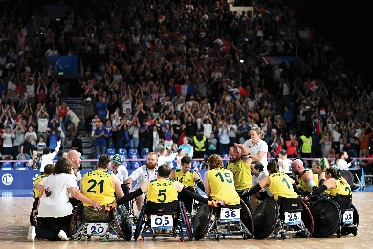 | 1,187 Paralympic athletes have represented Australia.  We call these athletes Paralympians.
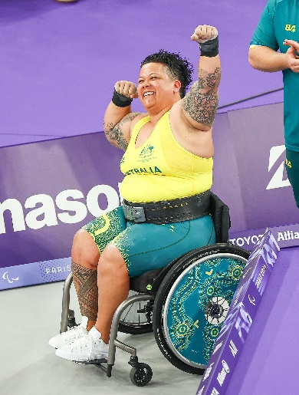 | We believe the Paralympic Games help improve the lives of people with disability.  This is very important.  This is because it shows great things that people with disability can do.
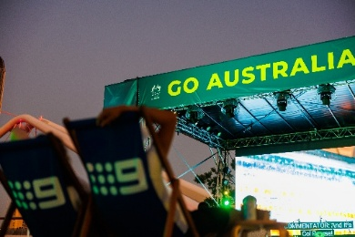 | The Paralympic Games are seen around the world by a big audience.

Our Purpose
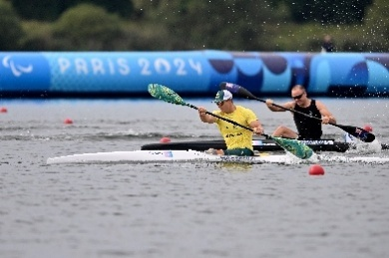 | Our purpose is ‘We exist to lead Paralympic sport and create a more inclusive world’.  This means that Paralympics Australia is here to help guide Paralympic sport.
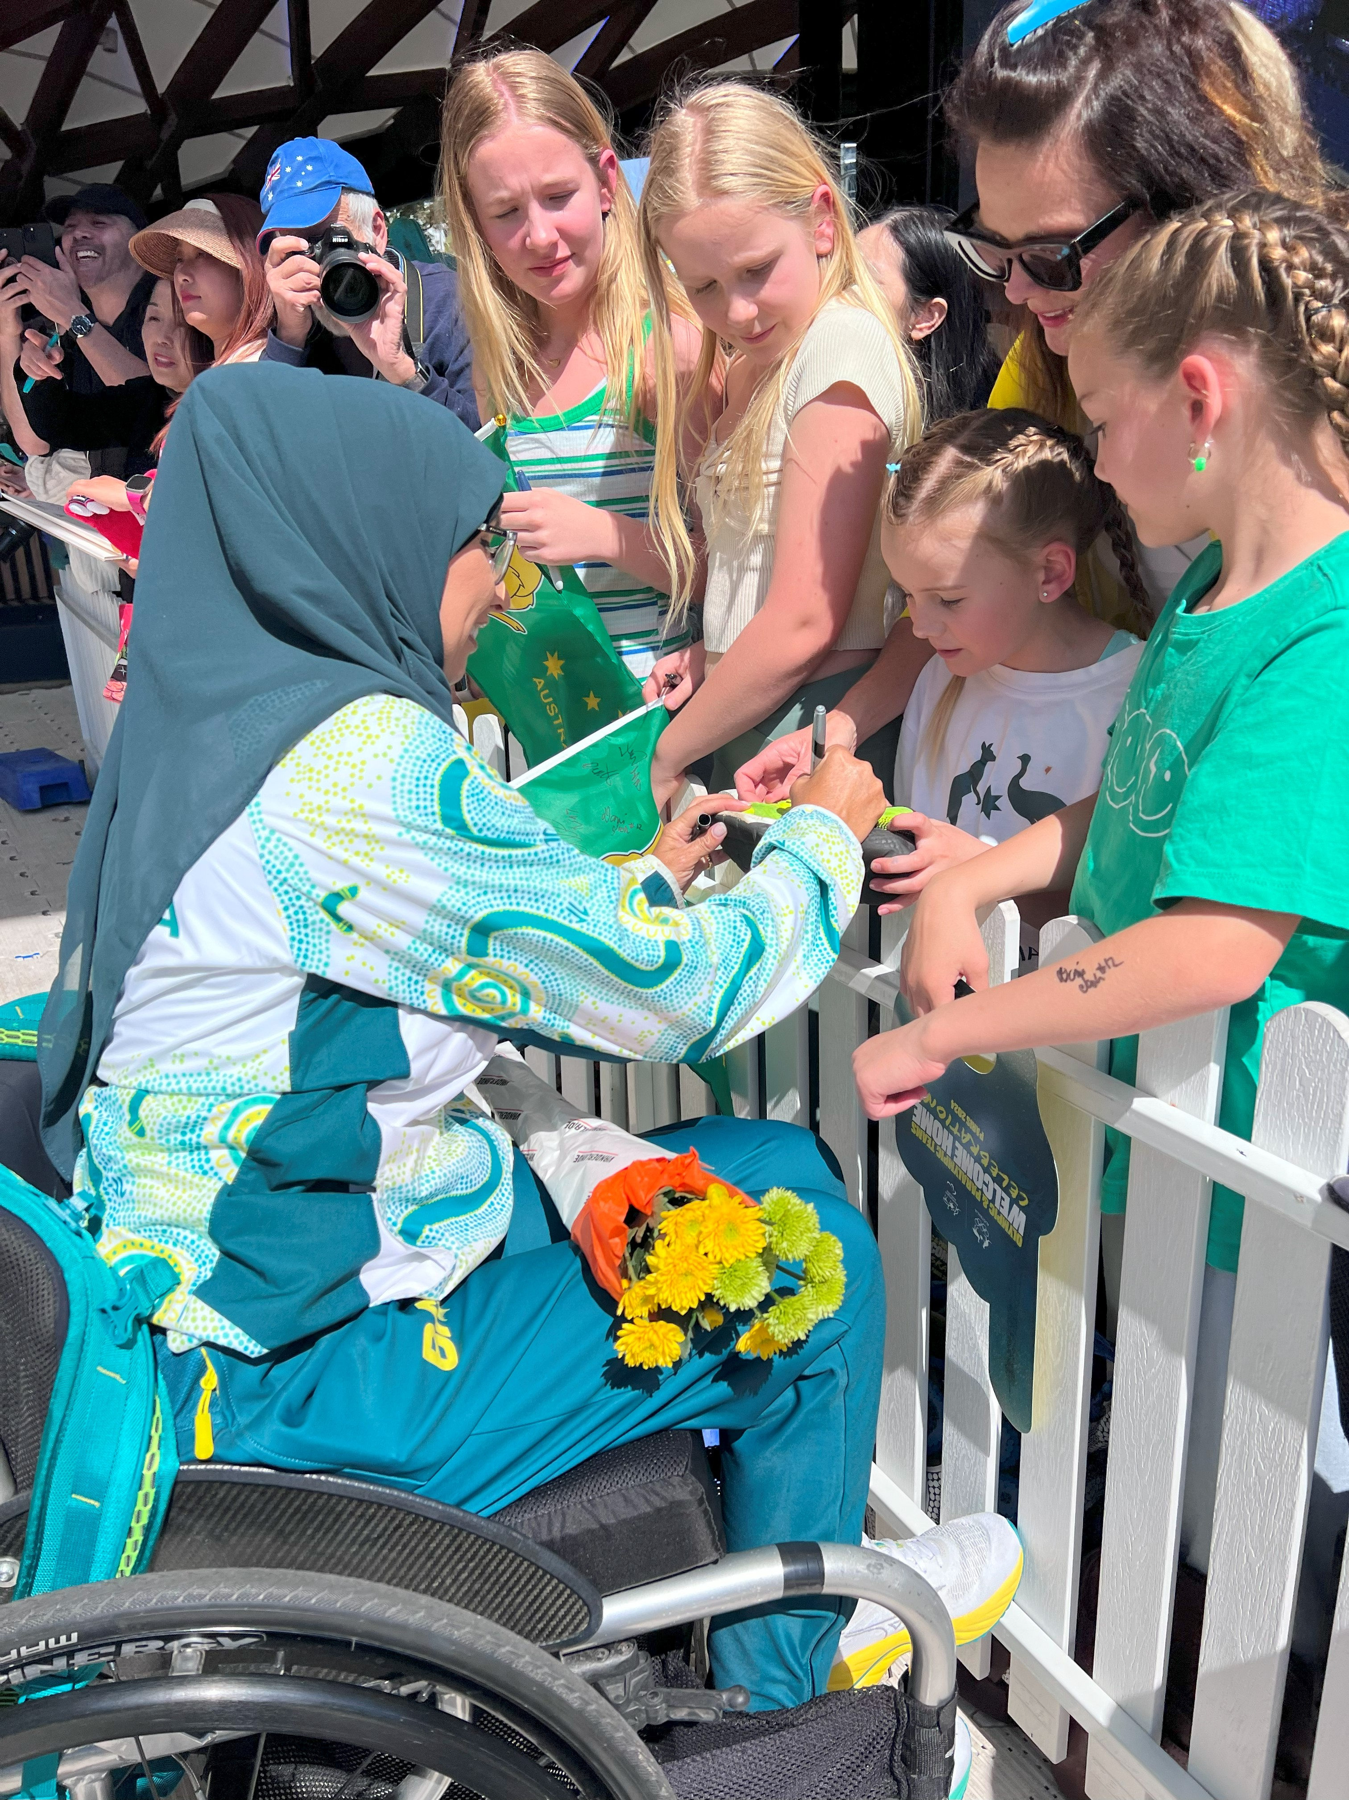 | We know Paralympic sport can help show that the world can include everyone.

Our Vision
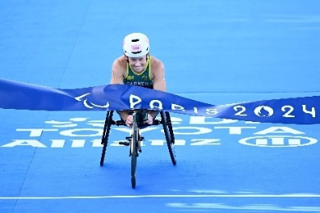 | Our vision is ‘We want to have the most successful generation of Paralympic sport in Australia’.  This means that we want the Paralympic athletes of today to be the best ever.

Our Ambitions
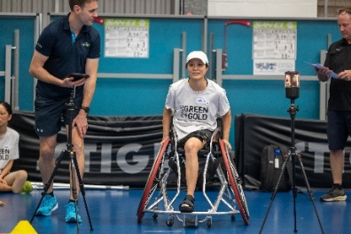 | Our ambitions are what we want to achieve.  We want the best opportunities for Paralympic sport in the world.  We want Paralympic athletes to do really great things.
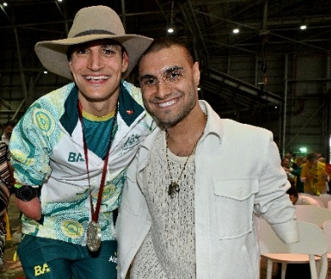 | We want Australians to be proud of the Australian Paralympic Team.  We want the Australian Paralympic Team to help make Australia a place where everyone is included.

What we achieved in Horizon 1 of our strategic plan
Horizon 1 was the first part of our strategic plan.

It began in March 2023.

We got some very good results. These include:
 | The Australian Government gave 54.9 million dollars to help Paralympic sport activities.  We thank the Federal and State governments for this support.  It helps us remove big barriers and get ready to do our best in Games in the future.
 | More sponsors than ever before supported the Australian Paralympic Team.  We thank them for being great partners.
 | More athletes took part in Para sport competitions.
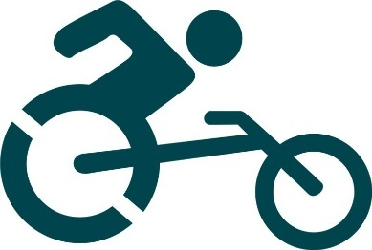 | Paralympic Units were set up. These help athletes all over Australia
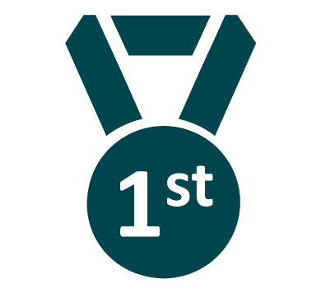 | We maintained the number 1 ranking as Australia’s most loved team.
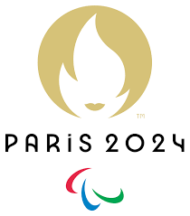 | Our Australian Paralympic Team went to the Paris 2024 Summer Paralympics.  We had 160 team members.  61 Paralympians went to their first Paralympic Games.  Australians set 5 world records.  We won 18 Gold medals, 17 Silver medals and 28 Bronze medals.

Our Strategy
 | Our Plan has 4 main areas to focus on.  We call these our strategic pillars.  Our strategic pillars are:
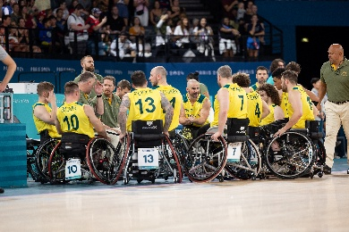 | Our Team
 | Our Ecosystem
 | Our Story
 | Our Future

Our Team

What we want to achieve
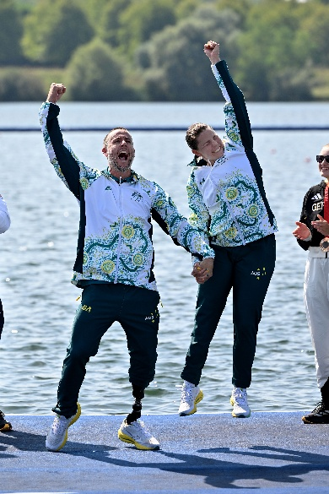 | A successful Australian Paralympic Team.

How we will achieve this
 | We will:  - Make sure athletes feel safe at the Paralympic Games.
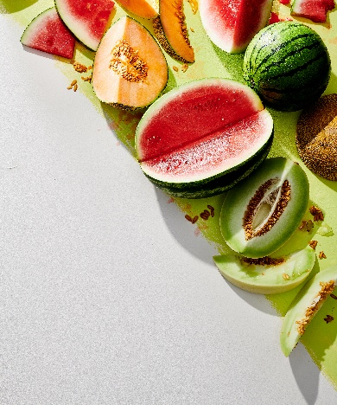 | - Make sure athletes have what they need to perform.
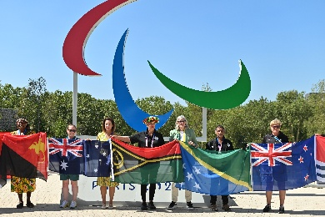 | - Help Paralympic activities in Oceania.
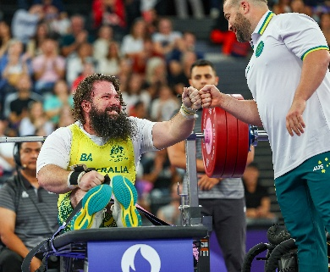 | We will also start new programs for participation, competition and coaching in Para powerlifting programs.  This is because Paralympics Australia is responsible for this Para powerlifting.

Our Ecosystem

What we want to achieve
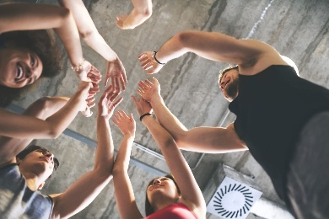 | We want all the organisations involved in Paralympic sport to work together.
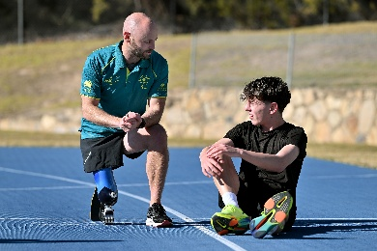 | Working together will provide the best opportunities for athletes.

How we will achieve this
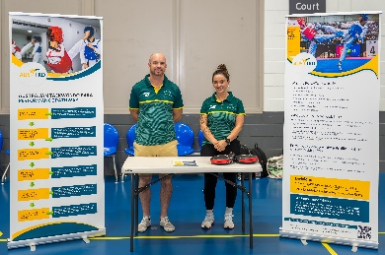 | We will:  - Work with organisations who will help Para athletes.
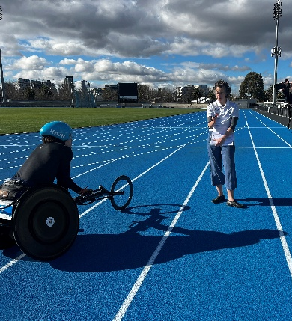 | - Improve classification opportunities for Para athletes.
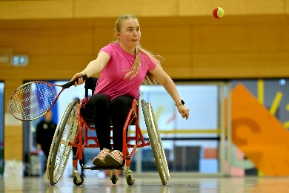 | - Help Para athletes to access equipment to compete.
 | - Have good relationships with organisations that are members of Paralympics Australia.
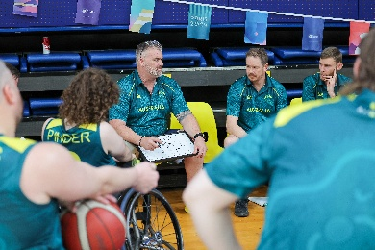 | - Work with past Paralympians to help them succeed when they stop competing.

3. Our Story

What we want to achieve
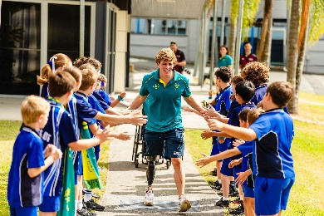 | We want to share great stories about Paralympic sport and the Australian Paralympic Team with everyone.
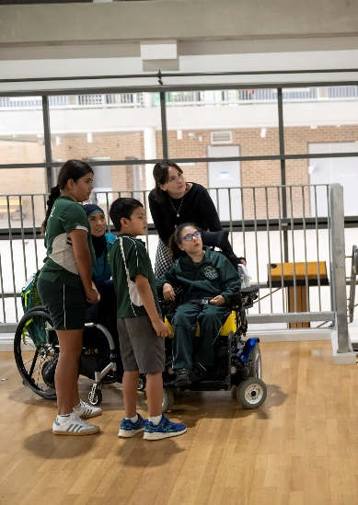 | We want to show everyone that Paralympic sport helps create a more inclusive world.

How we will achieve this
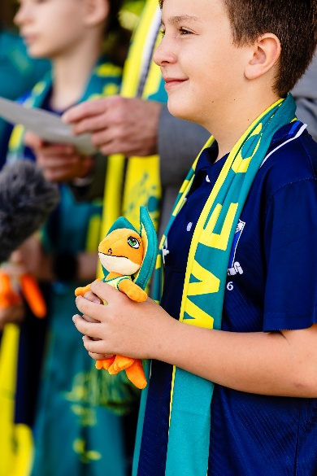 | We will:  - Tell great stories about Paralympic sport that make Australians proud.  - Make more people aware about Paralympic sport in Australia.  - Help Paralympians and Para athletes to share their stories in local communities.

4. Our Future

What we want to achieve
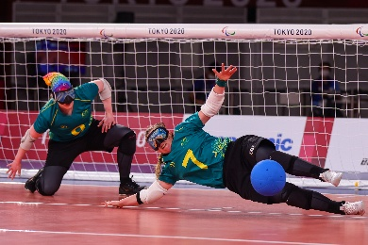 | We want to give people the best opportunity to take part in Paralympic sport.

How we will achieve this
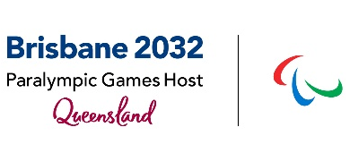 | We will:  - Help plan for the Brisbane 2032 Olympic and Paralympic Games.
 | - Find different ways to get money for Paralympics Australia, like fundraising, sponsorship and government support.
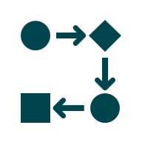 | - Set up good systems and processes for our staff.
 | - Keep working for equal money for Olympic and Paralympic sports.

What we need to achieve our goals
Good processes.

Clear steps to follow.
 | Support for our staff.
 | Work together with other groups.
 | Show our organisation values.  Organisation values guide what we do.  Our values are:  - Brave – not afraid.  - Limitless – can do anything.  - Tenacious – don’t give up.  - Proud – happy about what we do.

Why our strategic plan is important
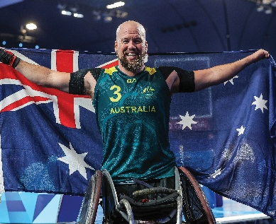 | The Australian Paralympic Team is Australia’s favourite national team.
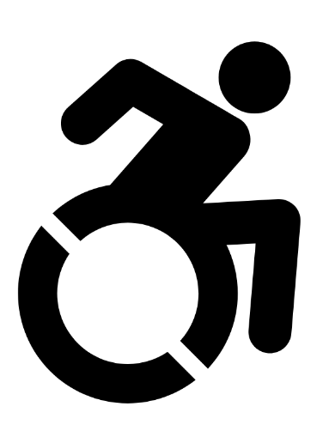 | There are 5.5 million people in Australia with disability.  This is 1.1 million people since 2018.
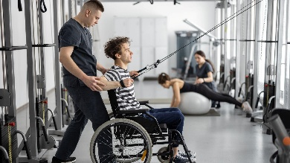 | Research shows people with disability are less likely to exercise than people without disability.
 | They are also less likely to have a job.  If they do have a job, they earn less than someone without a disability.
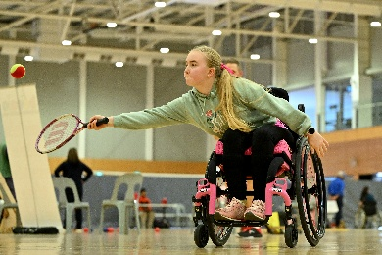 | We want to use Paralympic sport to help change this.

What success looks like
 | Our long-term goal is to have our best Games ever at the Brisbane 2032 Paralympics.
 | To do this, we have some things we need to achieve during the next 3 years and some things we need to achieve at Brisbane 2032.

What success will look like in Brisbane 2032 |  | How we get there
 | We want to win the most Gold medals |  | More chances for people to take part in Paralympic sport
 | The Australia team has 300+ Paralympians |  | Have a positive and friendly culture in the Australian Paralympic Team
 | The team is happy and able to perform at their best | 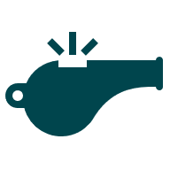 | Make sure there are chances for people to take part in Paralympic sport after Brisbane 2032.
 | Australians say good things about Paralympic sport | 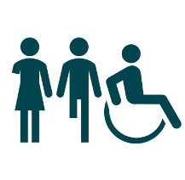 | The team includes everyone
 | We want to win 150 medals

About the Brisbane 2032 Olympic and Paralympic Games
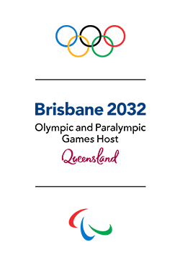 | The Brisbane 2032 Olympic and Paralympic Games will be a very special event.  It is one of the biggest sporting events in the world.  These Games will:  - Show how sport can include everyone.  - Celebrate people with disability.  - Give new chances for people with disability to succeed.
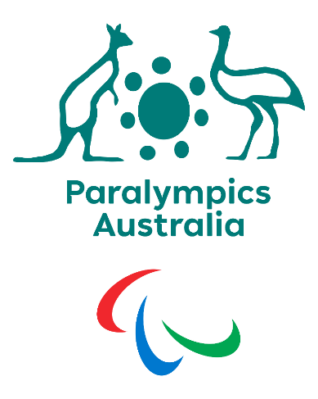  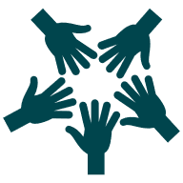 | Paralympics Australia is one of 9 partners helping to plan and run the Games.  We will:  - Support our athletes so they can do their best.  - Help Australia feel proud and united.  - Work for more Paralympic sport events to be held in Australia.

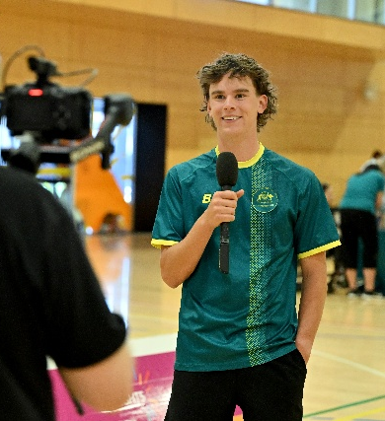 | The Brisbane 2032 Paralympic Games are not only about sport.  They will also help:  - Change how people see disability.
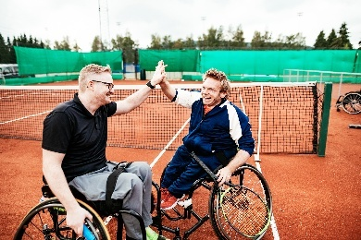 | - Build confidence in people with disability.
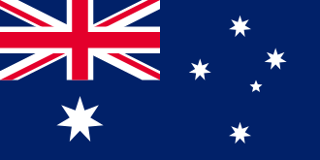 | - Create a stronger and fairer Australia.
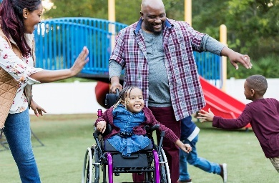 | - Show the world the power of diversity.

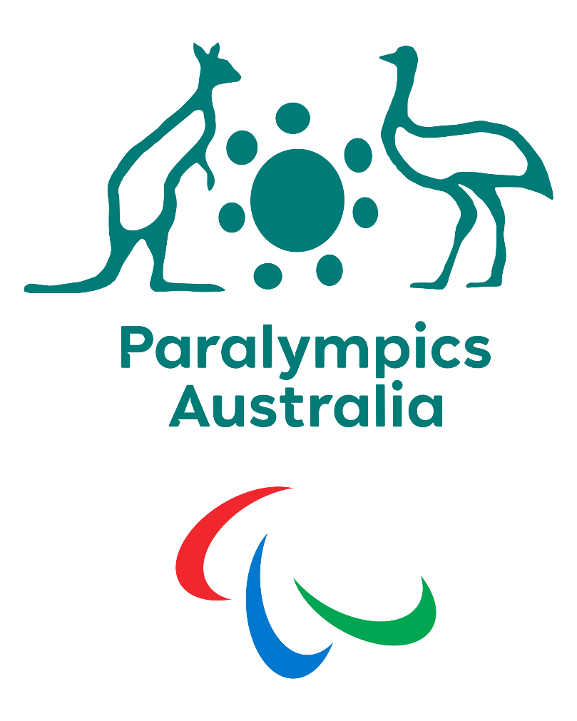

Follow us
- Facebook: www.facebook.com/AUSParalympics
- Instagram: www.instagram.com/AUSParalympics
- X: www.x.com/AUSparalympics
- LinkedIn: www.linkedin.com/company/AUSParalympics
- Tik Tok: www.tiktok.com/AUSParaTeam
- YouTube: www.youtube.com/AUSParaTeam
- Website: www.paralympic.org.au

Scan to the QR code to visit our website:
